Assignment 5
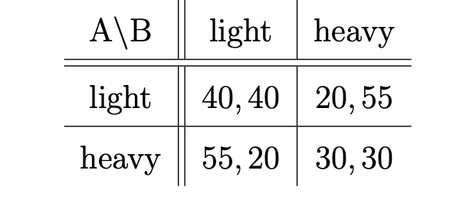

a)
its a prisoners dilemma because it has a strictly dominating Nash equilibrium in $NE=\{heavy,heavy\}$ which is not pareto efficient
b)
i) it is a Nash EQ if and only if there is never incentive to deviate to show this we
thus
$u\left(s_{1}^{gt},s_{2}^{gt}\right)=40·\frac{1}{1-δ}$
It is a NE as long as
$$40·\frac{1}{1-δ}=u\left(s_{1}^{gt},s_{2}^{gt}\right)≥u\left(s_{1}^{θ},s_{2}^{gt}\right) ∀θ$$
If player 1 has incentive to deviate then he will always do it in the first play because the “reward” gained from playing heavy isent discounted
Thus if it is a NE
$$40·\frac{1}{1-δ}≥55+30·\frac{δ}{1-δ}⇔40≥55-55·δ+30δ=55-25δ⇔25δ≥15⇔δ≥\frac{3}{5}$$
ii) yes any NE in a infinitely repeated game must be a subgame perfect NE

iii) in this setup we have the option to go back to the (light,light) repeated which means the minimum dicountfactor is at least as small as the one from before

iv)
this is never a NE, we let player 1 play the strategy alternating starting by playing heavy.
This always has higher payoff than the tf2t
this is always strictly better
to show this we determine the payoffs
$$u\left(s_{1}^{tf2t},s_{2}^{tf2t}\right)=40·\frac{1}{1-δ}$$
$$u\left(s_{1}^{alternating},s_{2}^{tf2t}\right)=55+40·δ+55·δ^{2}…=\sum_{i=0}^{∞}{55·δ^{2·i}+40·δ^{2i+1}}=55·\frac{1}{1-δ^{2}}+40·\frac{δ}{1-δ^{2}}$$

$$40·\frac{1}{1-δ}<55·\frac{1}{1-δ^{2}}+40·\frac{δ}{1-δ^{2}}=55·\frac{1}{(1+δ)(1-δ)}+40·\frac{δ}{(1+δ)(1-δ)}$$
$$⇔40<\frac{55}{1+δ}+40·\frac{δ}{1+δ}⇔40·\left(1+δ\right)<55+40·δ⇔40<55$$
Thus we have a strictly better strategy for all values of $δ≥0$ thus it is never a NE

